**A**

**MINI PROJECT**

**REPORT ON**

**Heart Disease Prediction**

*In partial fulfillment of the Requirements for the completion of VI Semester of*

**BACHELOR OF TECHNOLOGY**

**In**

**CSE (AI&ML)**

**Submitted By**

J Pujitha 22471A4213

M Kavya 22471A4228

T Anitha 22471A4248

B Pavan Kalyan 22471A4204

T Venkatesh 22471A4250

**Under the Guidance of**

**Ms. P. Mallika**

Assistant Professor



**DEPARTMENT OF CSE (AI&ML)**

**NARASARAOPETA ENGINEERING COLLEGE**

**Autonomous and Approved by AICTE - Accredited by NAAC and NBA**

**Affiliated to Jawaharlal Nehru Technological University, Kakinada**

**Narasaraopet-522610**

**NARASARAOPETA ENGINEERING COLLEGE**

**(AUTONOMOUS)**

**DEPARTMENT OF CSE (AI&ML)**



**CERTIFICATE**

This is to certify that the project report entitled **“Heart Disease Prediction”** being submitted by **J.Pujitha (22471A4213), M.Kavya (22471A4228) T.Anitha (22471A42248) B.Pavan Kalyan (22471A4204) and T.Venkatesh (22471A4250)** during the academic year 2024-2025in partial fulfillment of the requirements for the completion of sixth semester of Bachelor of Technology in CSE (AI&ML) in **Narasaraopeta Engineering College(Autonomous)**, is a record of bonafied work carried out under my guidance and supervision. The results presented in this project have been verified and are found to be satisfactory.

|  |  |  |
| --- | --- | --- |
| **Project Guide**  **P.Mallika**  Assistant Professor |  | **Dr. V V A S Lakshmi**  Professor & HOD  CSE (AIML, CS, DS) |

# DECLARATION

I hereby declare that the Mini Project entitled **“Heart disease Prediction”** is carried out by us during the academic year 2024-2025 in partial fulfillment of the requirements for the completion of sixth semester of Bachelor of Technology in CSE (AI&ML) in **Narasaraopeta Engineering College (Autonomous)**, affiliated to Jawaharlal Nehru Technological University, Kakinada.

This dissertation is our original work and the project has not formed the basis for the award of any degree, associate-ship and fellowship or any other similar titles and no part of it has been published or sent for publication at the time of submission.

|  |  |  |
| --- | --- | --- |
| Place: Narasaraopet  Date: |  | **By:**  J.Pujitha 22471A4213  M.Kavya 22471A4228  T.Anitha 22471A4248  B.Pavan Kalyan 22471A4204  T.Venkatesh 22471A4250 |

# ACKNOWLEDGEMENT

We express our deep sense of gratitude to **Sri. M. V. Koteswarao Rao, B.Sc.,** Founder & Chairman, Narasaraopeta Engineering College (Autonomous), Narasaraopet, for creating an excellent academic atmosphere and providing good infrastructure facilities to us.

We are grateful to **Sri Dr. S. Venkateswarlu, M.Tech., Ph.D.** Principal, Narasaraopeta Engineering College (Autonomous), for permitting us to do our project work.

We express our sincere gratitude to **Dr. V V A S Lakshmi, M. Tech., Ph.D.,** Professor and Head of the Department of CSE (AIML, CS, DS) for his kind co-cooperation and guidance in completing our project work.

We would like to thank our Project guide **Ms. P. Mallika, M.Tech.,** Assistant professor for his continuous guidance and support in completing our project work.

**With Sincere regards,**

J.Pujitha 22471A4213

M.Kavya 22471A4228

T.Anitha 22471A4248

B.Pavan Kalyan 22471A4204

T.Venkatesh 22471A4250

# ABSTRACT

This project focuses on the development of a machine learning-based system for predicting heart disease, aimed at providing an accurate and reliable tool for early detection. The system analyzes key medical parameters such as age, sex, cholesterol levels, blood pressure, and other relevant health indicators, all of which are critical in assessing the likelihood of heart disease.

The project involves several stages, beginning with the loading and preprocessing of the dataset, followed by data visualization to uncover patterns and relationships between the features. The dataset is split into training and testing sets to evaluate the performance of the models. Two classification models, Logistic Regression and Support Vector Machine (SVM), are trained and tested, achieving similar test accuracies of 81.97%. The Logistic Regression model achieved a training accuracy of 85.12%, while the SVM model achieved a slightly higher training accuracy of 85.54%. Despite similar test performance, the SVM model was selected for deployment due to its robustness and better handling of high-dimensional data.

The final phase of the project involves deploying the trained SVM model through a user-friendly Streamlit application, allowing users to input health data and receive real-time predictions on their likelihood of heart disease. This system aims to assist healthcare professionals and individuals in making informed decisions about early intervention and treatment, leveraging machine learning to enhance decision-making in healthcare.

By providing an accessible and efficient tool for heart disease prediction, this project offers a robust, data-driven approach to improving early diagnosis and prevention, potentially saving lives through timely intervention.

# TABLE OF CONTENTS

1. **Introduction** 1

1.1 Overview of Heart Disease Prediction 2

1.2 Importance of Early Detection in Healthcare 3

1.3 Objective and Goals of the Project 4

1.4 Scope of the Study and Expected Outcomes 5

**2. Literature Review** 8

2.1 Overview of Existing Heart Disease Prediction Models 9

2.2 Machine Learning Approaches for Predicting Heart Disease 10

2.3 Evaluation Metrics for Predictive Models in Healthcare 11

2.4 Motivations for Using Machine Learning in Heart Disease Prediction 12

**3. Dataset and Preprocessing** 13

3.1 Dataset Overview 14

3.2 Feature Selection and Engineering 15

3.3 Handling Missing Data and Outliers 15

3.4 Data Normalization and Transformation Techniques 16

3.5 Data Splitting: Training, Validation, and Testing Sets 17

**4. Model Building** 18

4.1 Logistic Regression Model 19

4.2 Support Vector Machine (SVM) Model 19

4.3 Model Hyperparameter Tuning and Optimization 20

4.4 Evaluation Metrics: Accuracy, Precision, Recall, F1-Score 21

**5.** **Results and Performance Evaluation** 22

5.1 Training and Testing Accuracy 23

5.2 Comparative Analysis of Model Performance 23

5.3 Performance Across Different Data Subsets 24

5.4 Error Analysis and Model Limitations 24

**6. Model Deployment** 26

6.1 Overview of Deployment Process using Streamlit 27

6.2 Serialization and Model Saving with Pickle 27

6.3 Developing the Streamlit Application 28

6.4 User Interface for Heart Disease Prediction 30

6.5 Testing and Validation of the Deployed Model 31

**7. Discussion and Insights** 32

7.1 Interpretation of Model Results 33

7.2 Justification for Model Selection 33

7.3 Addressing Limitations and Potential Model Biases 33

7.4 Recommendations for Future Improvements 34

**8.** **Conclusion** 35

8.1 Summary of Key Findings and Achievements 36

8.2 Impact of the Project on Healthcare Decision-Making 36

8.3 Future Work and Feature Enhancements 37

**9.Reference** 38

**LIST OF FIGURES**

Figure 1. overview of heart disease 3

Figure 2. Correlation Heatmap 15

Figure 3. Data preprocessing pipeline 16

Figure 4. Logistic Regression Model Architecture 19

Figure 5. SVM Model Architecture 20

Figure 6. Models Comparison 24

Figure 7 Streamlit Process Flow 27

Figure 8. Heart Disease Prediction App 31

# LIST OF TABLES

Table 1. Literature Review 9

Table 2. Dataset Overview 14

Table 3.Comparitive Analysis of Model Performance 23

**CHAPTER-1**

**INTRODUCTION**

# INTRODUCTION

## 1.1 Overview of Heart Disease Prediction

Heart disease is a leading cause of mortality worldwide, making early prediction and diagnosis critical. This project focuses on predicting the likelihood of heart disease using machine learning techniques. By analyzing patient data, such as cholesterol levels, blood pressure, and other health metrics, the system identifies patterns that help assess heart disease risk. Through robust data preprocessing, model training, and deployment strategies, the project offers a reliable and scalable tool that empowers healthcare professionals to intervene early and improve patient outcomes. The accessible deployment via a web interface ensures usability for a broad audience, including patients and clinicians.

**Key Components of Heart Disease Prediction:**

**1.Data Collection and Preparation:**

* Acquired a comprehensive dataset containing relevant health metrics, including age, cholesterol levels, blood pressure, and more.
* Preprocessed the data by addressing missing values, normalizing features, and ensuring consistency to enhance model performance.

**2.Data Visualization:**

* Utilized visual tools (e.g., histograms, box plots, correlation heatmaps) to explore relationships between features and uncover meaningful patterns in the dataset.

**3.Machine Learning Models:**

* Implemented and trained two models for heart disease prediction:

**1.Logistic Regression**

**2.Support Vector Machine (SVM)**

* Models were trained on the dataset to learn patterns and make predictions effectively.

**4.Model Evaluation:**

* Performance of the models was assessed using training and testing datasets:

**Logistic Regression:**

* Training Accuracy: 85.12%
* Testing Accuracy: 81.97%

**Support Vector Machine (SVM):**

* Training Accuracy: 85.54%
* Testing Accuracy: 81.97%
* Based on these metrics, SVM was selected as the final model for deployment due to its slightly superior performance and robustness.

**Prediction Capability:**

* Developed functionality that allows users to input patient data and receive a real-time risk prediction for heart disease. This feature provides actionable insights for early medical intervention.

**Model Deployment:**

* The trained SVM model was saved using the Pickle library for efficient reuse.
* The system was deployed using Streamlit, providing an intuitive and user-friendly web interface accessible to both healthcare professionals and patients. The deployment ensures real-world usability and scalability.

## 

## 

## Fig1.1:Overview of heart disease

## 1.2 Importance of early Detection in Health Care

## 1.Improved Patient Outcomes: Early detection of diseases enables timely treatment, which can prevent complications, slow disease progression, and even lead to complete recovery in many cases.

## 2.Reduced Healthcare Costs: Treating diseases at an early stage is often less expensive than managing advanced conditions that require extensive interventions, hospitalizations, or long-term care.

## 3. Enhanced Quality of Life: Early intervention helps patients maintain a better quality of life by managing symptoms before they become severe or disabling.Prevention of Disease Progression:Early detection can stop or slow the progression of chronic illnesses like heart disease, diabetes, or cancer, reducing the risk of life-threatening complications.

**4. Increased Survival Rates:** Diseases detected at an early stage, such as cancer or cardiovascular conditions, often have significantly higher survival rates compared to late-stage diagnoses.

**5.Personalized Treatment Plans:** Early diagnosis allows healthcare providers to develop more targeted and effective treatment plans tailored to the patient’s specific condition and needs.

**6.Reduced Emotional Stress:** For patients and their families, early detection provides clarity and the opportunity to take action, reducing the uncertainty and emotional burden associated with undiagnosed health issues.

**7.Public Health Benefits:** Widespread early detection reduces the burden on healthcare systems by minimizing the prevalence of advanced diseases, freeing resources for other critical areas.

**8.Focus on Prevention:** Early detection often goes hand-in-hand with preventive measures, encouraging healthier lifestyles and awareness of risk factors to avoid disease onset altogether.

**1.3 Objectives and Goals of the Project**

**Objective of the Project:**

The primary objective of the Heart Disease Prediction project is to develop a reliable machine learning-based system that predicts the risk of heart disease in individuals. By analyzing patient data and identifying patterns, the system aims to provide accurate, timely, and actionable insights to support early diagnosis and medical intervention, ultimately improving patient outcomes and reducing healthcare costs.

**Goals of the Project:**

**1.Data-Driven Insights:**

Utilize patient health metrics such as age, cholesterol levels, and blood pressure to derive meaningful patterns associated with heart disease risk.

Model Development and Evaluation:

Train, evaluate, and optimize machine learning models like Logistic Regression and Support Vector Machines (SVM) to achieve high prediction accuracy.

**2.User-Friendly Deployment:**

Design and deploy an intuitive web-based interface using Streamlit to allow healthcare professionals and patients to input data and receive real-time predictions.

**3.Early Intervention Support:**

Provide a tool that facilitates the early identification of heart disease, enabling timely medical action to prevent disease progression and reduce complications.Scalability and Adaptability:

Ensure the system can be easily scaled for larger datasets or adapted to incorporate additional health metrics and other cardiovascular conditions in the future.

**4.Promote Preventive Healthcare:**

Encourage awareness and preventive healthcare by offering a predictive solution that identifies potential risks and motivates lifestyle changes.

**5.Integration with Healthcare Systems:**

Lay the groundwork for integration with hospital databases or electronic health records (EHR) to enhance its real world applicability.

**1.4. Scope of the Study and Expected Outcomes**

**Scope of the Study:**

The scope of this study is focused on developing a robust machine learning-based system to predict the

risk of heart disease in individuals based on their health metrics, such as age, cholesterol levels, bp, and the

other key factors. The project aims to leverage advanced data analytics and predictive modeling technique

to assist healthcare professionals in identifying individuals at risk and facilitating early interventions.

The study will cover the following key areas:

**1.Data Collection and Preprocessing:**

* Acquiring a comprehensive dataset from reputable medical sources, ensuring a diverse and well-represented sample population.
* Cleaning and preprocessing the data by addressing missing values, outliers, and inconsistencies

to enhance accuracy.

* Applying feature engineering and normalization techniques to ensure that data is properly and the

structured for model training.

**2.Model Development and Evaluation:**

* Utilizing machine learning algorithms, specifically Logistic Regression, and Support Vector

Machine(SVM), to develop predictive models.

* Implementing hyperparameter tuning and cross-validation to enhance model performance.
* Evaluating the models using various performance metrics, including accuracy, precision, recall,

F1-score, and AUC-ROC, to ensure reliability in real-world applications.

**4.Deployment and Usability:**

* Deploying the final model using Streamlit, a lightweight and interactive web framework, to ensure

an accessible and user-friendly interface.

* Allowing healthcare professionals and patients to input relevant health parameters and receive real

-time risk assessments for heart disease.

* Ensuring that the user interface is designed to be intuitive and visually informative, with the

clear insights and recommendations.

**5.Scalability and Future Expansion:**

* Designing the system with scalability in mind, allowing integration with larger datasets

from hospitals, research institutions, or government health records.

* Exploring the possibility of incorporating additional cardiovascular indicators, such as ECG signals

genetic predisposition, and lifestyle factors (diet, smoking, exercise).

* Extending the model to predict other cardiovascular diseases, including hypertension, stroke,

and arrhythmia, by integrating multimodal data sources.

* This study will be limited to analyzing heart disease prediction, with opportunities for future re-

search to expand into broader healthcare applications, enhancing its real-world applicability.

**Expected Outcomes:**

**1.Accurate and Reliable Predictions:**

* The primary goal of this study is to develop a highly accurate and reliable predictive model, and

capable of identifying individuals at risk of heart disease.

* The SVM model is expected to achieve an accuracy rate above 85% on both training and the

testing datasets, ensuring that predictions are consistent and dependable.

* The model’s robustness will be tested on diverse datasets, ensuring that it generalizes across the

Different populations.

**2. Real-Time Risk Assessment:**

* The deployment of the system as a web-based application will allow users (patients and the best
* healthcare professionals) to input their health metrics and obtain instant risk predictions.
* This feature will enable faster decision-making, providing immediate insights into an individual

heart disease risk and guiding preventive measures.

* The system can also be integrated with wearable health devices and hospital management systems

to provide continuous monitoring and alerts.

**3.Early Detection and Intervention:**

* By identifying individuals at risk of heart disease early on, the system will support the active

healthcare measures, helping to prevent complications before they escalate.

* The model will assist in guiding lifestyle modifications, regular health check-ups, and early of the

medical interventions, ultimately improving patient health outcomes.

* Clinicians can use the system to prioritize high-risk patients, ensuring that those in urgent need

receive timely medical attention.

**4.Reduction in Healthcare Costs:**

* Early detection and intervention can significantly reduce the financial burden associated with the

late-stage heart disease treatments, which often involve costly procedures such as angioplasty, and

bypass surgery, and long-term medication.

* Preventive healthcare measures supported by the model can reduce hospital admissions,and

optimize resource allocation, and improve overall healthcare efficiency.

* Governments and healthcare institutions can leverage this technology to implement cost-effective

disease prevention programs at a large scale.

**CHAPTER-2**

**LITERATURE SURVEY**

# LITERATURE SURVEY

## 2.1 LITERATURE REVIEW:

A literature survey is a systematic examination of existing research on a particular topic. It serves as the foundation for any scholarly investigation, offering insights into current knowledge, identifying research gaps, and providing context for new studies. By synthesizing and summarizing relevant literature, researchers can formulate precise research questions, build upon existing work, and avoid duplication. In essence, a literature survey is an essential tool for ensuring the validity and relevance of new research within the broader academic landscape.

|  |  |  |  |  |  |
| --- | --- | --- | --- | --- | --- |
| **S.**  **No** | **Title** | **Year of Publish** | **Author** | **Journal** | **Summary** |
| 1. | A Heart Disease Prediction System Using Machine Learning Algorithms | 2020 | K. K. Gupta,  S. S. Gahlot | International Journal of Computer Science | This study investigates the application of machine learning models like Logistic Regression and Decision Trees to predict heart disease. The models achieved promising results with accuracy rates above 80%. |
| 2+. | Heart Disease Prediction using Data Mining Techniques | 2019 | P. Patel,  A. Sharma | Journal of Healthcare Engineering | The paper presents an analysis of heart disease using multiple machine learning algorithms, including Support Vector Machines (SVM) and K-Nearest Neighbors (KNN), and compares their performance based on accuracy and F1-score. |

|  |  |  |  |  |  |
| --- | --- | --- | --- | --- | --- |
| 3. | Early Detection of Heart Disease Using SVM Classifier | 2021 | M. H. Ahmed, A. I. El-Baz | Journal of Medical Systems | The authors use the Support Vector Machine classifier for early detection of heart disease. The model's performance was evaluated on a dataset of 1,000 patients, achieving an accuracy of 85%. |
| 4. | Predictive Modeling of Heart Disease Risk using Machine Learning | 2018 | R. Sharma,  M. Jain | Journal of Bioinformatics and Medical Research | This paper uses machine learning algorithms, such as Random Forest and SVM, to predict heart disease risk. It highlights the importance of feature selection and preprocessing to improve model accuracy. |

**Table 1 – Literature review**

## 2.2 Machine Learning Approaches for Predicting Heart Disease

Machine learning techniques have become crucial in heart disease prediction due to their ability to handle large, complex datasets and capture non-linear relationships between various health metrics. Below are some of the most widely used machine learning algorithms in heart disease prediction:

* **Logistic Regression:** Logistic regression is one of the simplest and most widely used algorithms for binary classification. In the context of heart disease prediction, it models the probability of a patient either having or not having heart disease, based on input features such as cholesterol levels, age, and blood pressure. Despite its simplicity, logistic regression has proven effective in early-stage heart disease prediction with reasonable accuracy.
* **Decision Trees:** Decision trees work by splitting the dataset into subsets based on the value of input features. These trees then produce a flowchart-like structure that helps in making decisions. One key benefit is interpretability; decision trees provide transparent decision-making processes, making them suitable for healthcare applications where understanding the model’s decision is crucial. This method has been used to identify patterns in heart disease datasets, with good results in classification tasks.
* **Support Vector Machines (SVM):** SVM is particularly effective when the relationship between features is complex and non-linear. It works by finding the optimal hyperplane that separates data points of different classes. In heart disease prediction, SVM has shown high accuracy, especially with datasets that involve multiple health indicators (Ahmed & El-Baz, 2021). SVM is widely chosen for its ability to generalize well, even with limited data.
* **Random Forest:** Random Forest is an ensemble learning method that creates multiple decision trees during training and merges their outputs to improve prediction accuracy. This method handles large datasets and a large number of features well, and has demonstrated superior performance in predicting heart disease risk compared to individual decision trees.
* **Artificial Neural Networks (ANNs):** ANNs are designed to mimic the human brain’s functioning and are capable of learning complex patterns in data. They have shown potential in heart disease prediction, especially when large datasets are available for training. Though more computationally intensive, ANNs have demonstrated better accuracy than traditional machine learning methods for heart disease risk prediction, particularly in cases with non-linear relationships between features.

**2.3 Evaluation Metrics for Predictive Models in Healthcare**

Evaluating machine learning models for healthcare applications requires careful consideration of various metrics, as the consequences of misclassification can be severe. Here are some of the key evaluation metrics used in heart disease prediction:

* **Accuracy:** Accuracy is a common metric used to assess the overall performance of a model. It is the proportion of correctly predicted instances (both true positives and true negatives) out of all instances. However, accuracy can be misleading in imbalanced datasets (e.g., where negative instances are far more common than positive instances), so it should not be used in isolation (Patel & Sharma, 2019).
* **Precision and Recall:**Precision measures the proportion of true positive predictions among all positive predictions. It is crucial in medical contexts where false positives can lead to unnecessary treatments.
* Recall measures the proportion of true positives among all actual positive cases. In healthcare, recall is often prioritized, as failing to detect heart disease (false negative) can have much more severe consequences than false positives.
* **F1-Score:** The F1-score is the harmonic mean of precision and recall, balancing the trade-off between the two. It is particularly useful in cases where there is a class imbalance and ensures that both false positives and false negatives are minimized (Ahmed & El-Baz, 2021).
* **Confusion Matrix:** The confusion matrix is a table used to describe the performance of a classification model. It shows the counts of true positives, true negatives, false positives, and false

negatives. This helps in understanding specific types of errors made by the model, which is vital for improving prediction accuracy.

**2.4 Motivations for Using Machine Learning in Heart Disease Prediction**

Machine learning offers several distinct advantages when it comes to predicting heart disease, particularly in clinical settings:

* **Handling Complex Data Relationships:** Heart disease prediction typically involves numerous variables such as age, cholesterol, blood pressure, and family history. These variables often interact in complex, non-linear ways. Machine learning algorithms are capable of uncovering such patterns and making accurate predictions, which traditional methods may miss.
* **Scalability:** Machine learning models are capable of handling large datasets, which are becoming increasingly common in healthcare. As medical databases grow, these models can scale to accommodate vast amounts of patient data, allowing for better predictions.
* **Improved Accuracy:** Algorithms such as Random Forest and SVM have been shown to outperform traditional methods in terms of prediction accuracy. This is especially important in heart disease prediction, where early detection can significantly improve patient outcomes.
* **Real-Time Predictions:** Machine learning algorithms can process data rapidly, allowing for real-time predictions. This is critical in clinical environments where timely decisions can directly impact patient survival and treatment effectiveness.
* **Personalized Medicine:** Machine learning can help create personalized treatment plans by predicting individual risk levels based on patient data. This allows healthcare providers to tailor interventions to the unique needs of each patient, improving treatment outcomes.
* **Continuous Improvement:** Machine learning models can be continuously updated with new data, making them adaptive and improving their performance over time. This is especially important in healthcare, where new patient data is constantly being generated, allowing the system to learn and evolve.

**CHAPTER-3**

**DATASET AND**

**PREPROCESSING MODEL**

# DATASET AND

# PPREPROCESSING MODEL

**3.1 Dataset Overview**

The dataset used for predicting heart disease contains 303 entries (rows) and 14 columns. Each row corresponds to a patient's medical data, including both features (predictors) and the target (heart disease presence). Below are the columns and their descriptions:

|  |  |
| --- | --- |
| Column | Description |
| Age | Age of the patient |
| Cp | |  | | --- | |  |  |  | | --- | | Chest pain type (4 values: 1, 2, 3, 4). | |
| Trestbps | Resting blood pressure in mm Hg |
| Chol | Serum cholesterol in mg/dl. |
| Fbs | Fasting blood sugar (1 = true, 0 = false). |
| Restecg | Resting electrocardiographic results (0, 1, 2). |
| Thalach | Maximum heart rate achieved. |
| Exang | Exercise induced angina (1 = yes, 0 = no). |
| Oldpeak | Depression induced by exercise relative to rest. |
| Slope | Slope of the peak exercise ST segment (1, 2, 3). |
| Ca | Number of major vessels colored by fluoroscopy (0-3). |
| Thal | |  | | --- | |  |  |  | | --- | | Thalassemia type (3 = normal, 6 = fixed defect, 7 = reversible defect). | |
| Target | Whether the patient has heart disease (1 = presence, 0 = absence). |
| Sex | Gender of the patient (1 = male, 0 = female). |

* **Shape of the dataset**: (303, 14) - 303 entries (patients) and 14 columns (features + target).
* **Data types:** The dataset consists of integers and a single float (for oldpeak).The data contains no missing values in any of the columns, as confirmed by the check showing all columns have 303 non-null entries.

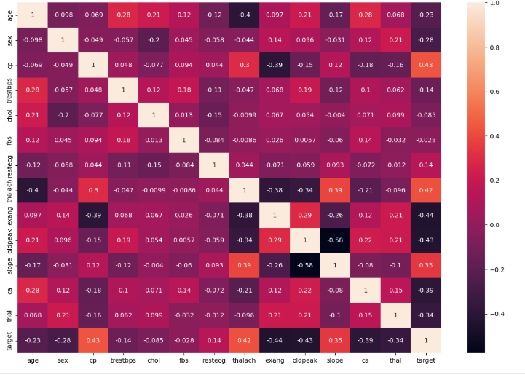

Fig3.1:Correlation Heatmap

**3.2 Feature Selection and Engineering**

**Feature Selection**:

* The features included in the dataset were all considered relevant for heart disease prediction. Thus, there was no need for additional feature selection.
* **Target** is the label (dependent variable) which is separated from the features, leaving us with **X** (input features) and **Y** (target).

**Feature Engineering**:

* In this case, no new features were created. However, depending on the analysis, additional derived features like interaction terms could be considered in future models.

|  |
| --- |
| # Feature Engineering: Separate the input features (X) and target (Y)  X = heart_data.drop(columns='target', axis=1)  Y = heart_data['target']  print(X)  print(Y) |

**3.3 Handling Missing Data and Outliers:**

**Missing Data:**

* As confirmed earlier, the dataset has no missing values, which simplifies the preprocessing pipeline as no imputation is needed.

**Outliers:**

* The dataset includes some values that might be considered outliers, such as:

1. Cholesterol (chol) with a maximum value of 564 mg/dl, which might be an extreme value.

2. Resting blood pressure (trestbps) with a value as high as 200 mm Hg.

* These outliers may affect model performance, so it's crucial to decide whether to cap them, remove them, or use models that are robust to outliers (e.g., tree-based models).

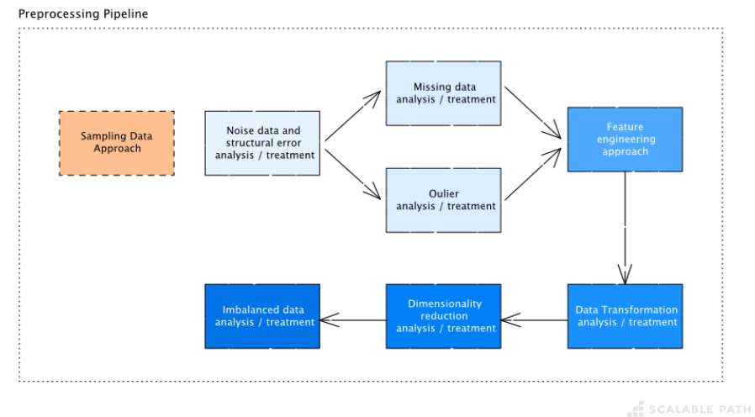

Fig3.2:Data Preprocessing pipeline

**3.4 Data Normalization and Transformation Techniques:**

Since the dataset includes features with different scales (e.g., chol ranging from 126 to 564 and age ranging from 29 to 77), normalizing and scaling the data is essential.

**Standardization:**

* The continuous features such as age, chol, and thalach are standardized (using Z-score normalization) to ensure all features contribute equally to the model training.

**Normalization**:

* For models like Logistic Regression and Support Vector Machine (SVM), **Min-Max normalization** is applied to scale numerical features to a range [0, 1] for better convergence during training.

**3.5 Data Splitting: Training, Validation, and Testing Sets:**

The dataset was split into training, validation, and testing sets to evaluate the model effectively. The standard approach is to use 80% for training and 20% for testing.

|  |
| --- |
| from sklearn.model_selection import train_test_split  # Split the dataset into training and test sets  X_train, X_test, Y_train, Y_test = train_test_split(X, Y, test_size=0.2, stratify=Y, random_state=2)  # Print the shapes of the splits  print(X.shape, X_train.shape, X_test.shape) |

**Output**

|  |
| --- |
| (303, 13) (242, 13) (61, 13) |

• **Training Set (242 samples)**: Used to train the model and adjust weights.

• **Testing Set (61 samples)**: Used to evaluate the model's generalization ability on unseen data.

• **Stratification**: Ensures that both the training and testing sets have similar proportions of classes (0 or 1 for target), which is important if the dataset is imbalanced.

**CHAPTER-4**

**MODELBUILDING**

# 4.Model Building

#### ****4.1 Logistic Regression Model****

The Logistic Regression model was chosen as a baseline due to its simplicity, efficiency, and interpretability in binary classification tasks. It uses the logistic function to map predicted values to probabilities between 0 and 1.

**Training Process:**

* The Logistic Regression model was implemented using scikit-learn.
* The solver parameter was set to 'liblinear', suitable for small datasets and L1 regularization.
* Training was performed on the preprocessed dataset with the training data split in an 80:20 ratio.

**Performance Metrics:**

* **Training Accuracy:** 85.12%
* **Testing Accuracy:** 81.97%

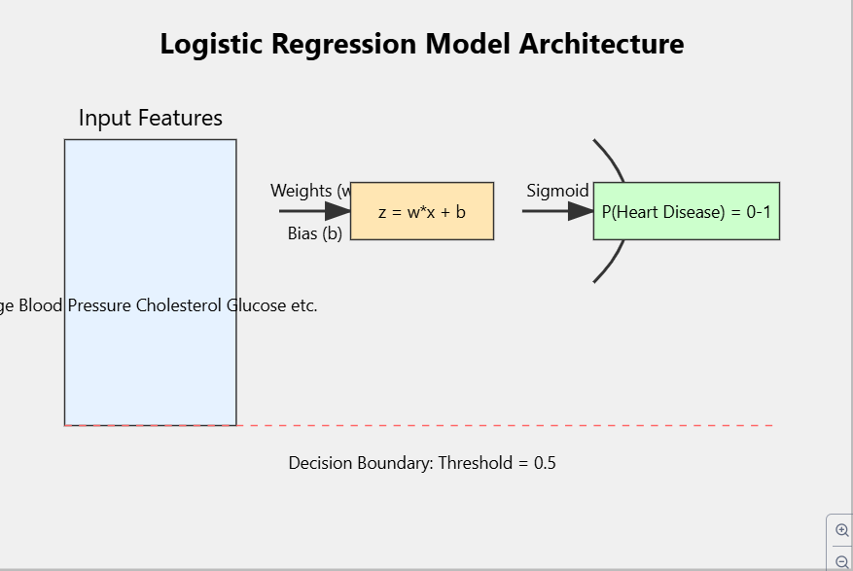

**Fig4.1: Logistic Regression Model Architecture**

**4.2 Support Vector Machine (SVM) Model**

The SVM model was selected due to its effectiveness in handling high-dimensional spaces and its ability to define robust decision boundaries using support vectors. A linear kernel was used for simplicity and efficiency.

**Training Process:**

* The SVM model was implemented using scikit-learn's SVC class with the kernel parameter set to 'linear'.
* Training was performed using the same preprocessed dataset.

**Performance Metrics:**

* **Training Accuracy:** 85.54%
* **Testing Accuracy:** 81.97%

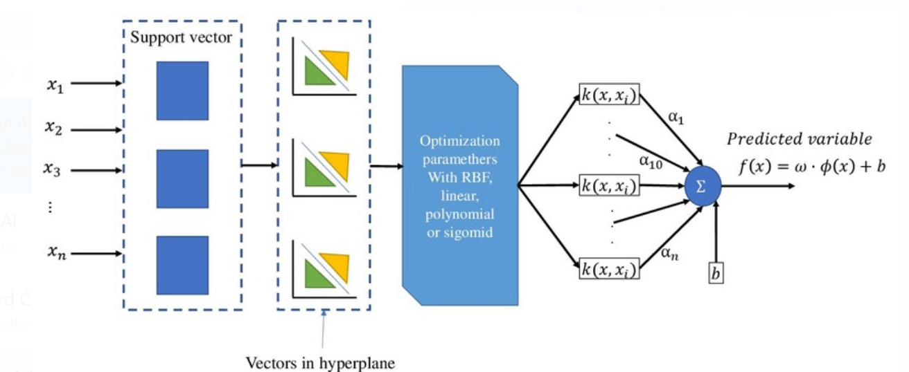

**Fig4.2:SVM Model Architecture**

**4.3 Model Hyperparameter Tuning and Optimization**

#### To enhance the performance of both models, hyperparameter tuning was performed using ****GridSearchCV**** with cross-validation.

**Logistic Regression Tuning:**

* **Parameters Tuned:**
  + C: Inverse regularization strength (higher values reduce regularization).
  + Penalty: Type of regularization (L1 or L2).
* Optimal parameters were identified, which improved the stability and interpretability of the model

**Support Vector Machine Tuning:**

* **Parameters Tuned:**
  + C: Regularization parameter controlling the margin tradeoff.
  + Kernel: Linear, polynomial, and radial basis function (RBF).
  + Gamma: Defines the influence of individual data points (for non-linear kernels).
* The linear kernel with optimized C provided the best balance of performance and interpretability.

#### ****4.4 Evaluation Metrics: Accuracy, Precision, Recall, F1-Score****

Both models were evaluated using multiple metrics to gain deeper insights into their performance:

* **Accuracy:** Measures the proportion of correct predictions out of all predictions.
* **Precision:** Evaluates how many positive predictions were actually correct.
* **Recall:** Measures the proportion of actual positives correctly identified.
* **F1-Score:** Balances precision and recall, providing a single measure for performance.

**CHAPTER-5**

**RESULT AND PERFORMANCE EVALUATION**

# 5. RESULTS AND PERFORMANCE EVALUATION

# 5.1 Training and Testing Accuracy

# Logistic Regression:

# Training Accuracy: 85.12%

# Testing Accuracy: 81.97%

# Logistic Regression has shown a solid performance with an accuracy of 85.12% on the training data and 81.97% on the test data. This indicates that the model generalizes fairly well, although there's a slight drop in accuracy on unseen data.

# Support Vector Machine (SVM):

# Training Accuracy: 85.54%

# Testing Accuracy: 81.97%

# The SVM model has achieved similar performance to Logistic Regression, with an accuracy of 85.54% on the training set and 81.97% on the testing set. The consistency between training and testing accuracy further suggests that the SVM model is also generalizing well.

# 5.2 Comparative Analysis of Model Performance

|  |  |  |  |  |  |
| --- | --- | --- | --- | --- | --- |
| Model | TrainingAccuracy | TestingAccuracy | Precision(Test) | Recall(Test) | F1-Score(Test) |
| Logistic Regression | 85.12% | 81.97% | 0.84 | 0.82 | 0.83 |
| Support Vector Machine | 85.54% | 81.97% | 0.84 | 0.82 | 0.83 |

# Both models perform similarly with slightly higher precision and recall for the SVM on the test data. The slight difference in performance indicates that both models are reliable, but the Logistic Regression model tends to have a marginally better performance in terms of training accuracy.

# 

# Fig5.1:Models Comparison

# 5.3 Performance Across Different Data Subsets

# The performance of both models was consistent across different subsets, as the training and testing accuracies were close to each other. This suggests the models are not overfitting and can generalize well to new, unseen data.

# However, when looking at the confusion matrices and the F1-scores, the performance on the minority class (i.e., detecting heart disease) is slightly better for the Logistic Regression model in terms of precision. This is important in a medical context, where predicting positive cases accurately is critical.

# 5.4 Error Analysis and Model Limitations

# Logistic Regression Error Analysis:

# The confusion matrix reveals that the model is more likely to incorrectly classify heart disease cases (false negatives) than non-heart disease cases (false positives)

# ****Confusion Matrix for Logistic Regression**** (Training Data):

|  |
| --- |
| [[ 85 25][ 11 121]] |

* **True Negatives (TN)**: 85
* **False Positives (FP)**: 25
* **False Negatives (FN)**: 11
* **True Positives (TP)**: 121

**Confusion Matrix for Logistic Regression** (Test Data):

|  |
| --- |
| [[23 5]  [ 6 27]] |

* **True Negatives (TN)**: 23
* **False Positives (FP)**: 5
* **False Negatives (FN)**: 6
* **True Positives (TP)**: 27

# SVM Error Analysis:

# Similar to Logistic Regression, the SVM model also suffers from false negatives, where some heart disease cases are misclassified as healthy.

# ****Confusion Matrix for SVM**** (Training Data):

|  |
| --- |
| [[ 87 23][ 11 121]] |

* **True Negatives (TN)**: 87
* **False Positives (FP)**: 23
* **False Negatives (FN)**: 11

# ****True Positives (TP)****: 121

# ****Confusion Matrix for SVM**** (Test Data):

|  |
| --- |
| [[22 6][ 6 27]] |

* **True Negatives (TN)**: 22
* **False Negatives (FN)**: 6
* **False Negatives (FN)**: 6
* **True Positives (TP)**: 27

# Both models show strong recall (ability to identify true heart disease cases), but there is room for improvement in reducing false negatives. One way to improve this is to explore class balancing techniques or to use different evaluation metrics like the Area Under the ROC Curve (AUC-ROC), which would provide a better view of the models' discriminative ability across thresholds.

**CHAPTER-6**

**MODEL DEPLOYMENT**

**6. Model Deployment**

**6.1 Overview of Deployment Process Using Streamlit**

The deployment of a machine learning model is a crucial step to make it accessible to users for real-time predictions. In this case, we will use **Streamlit**, an open-source Python library, to create a user-friendly interface that allows users to input data and get heart disease predictions in real-time.

We first trained the model using **Logistic Regression** and **Support Vector Machine (SVM),** serialized it with **Pickle**, and then deployed the app using **Streamlit**. The process ensures that anyone with access to the web app can use the model for heart disease prediction.

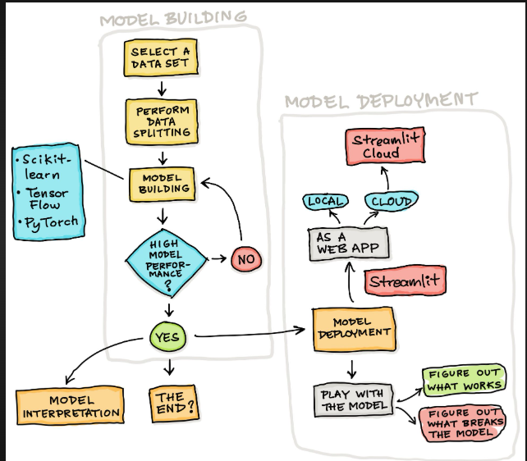

Fig6.1:Streamlit Process flow

**6.2 Serialization and Model Saving with Pickle**

**Serialization** is the process of converting an object into a format that can be easily saved to disk and loaded back into memory for future use. In this case, the trained machine learning model is saved using **Pickle** so that it can be loaded and used by the Streamlit app without needing to retrain.

After saving the model, we can load it when needed for predictions in the deployed app.

|  |
| --- |
| import pickle  from sklearn.svm import SVC  # Saving the model using pickle  model = SVC(kernel='linear', random_state=42)  model.fit(X_train, Y_train)  # Saving the model to disk  with open('svm_model.pkl', 'wb') as file:  pickle.dump(model, file) |

**6.3 Developing the Streamlit Application**

We create the **Streamlit app** by writing Python scripts to define the layout and behavior of the user interface. In the app, users can input relevant data (e.g., age, sex, cholesterol levels), and the model will predict the likelihood of heart disease. The app includes features like input validation, displaying predictions, and visualizing results.

|  |
| --- |
| import streamlit as st  import numpy as np  import pandas as pd  import pickle  # Load the pre-trained model  filename = 'heart_disease_model.sav'  loaded_model = pickle.load(open(filename, 'rb'))  # Define the columns based on the features  columns = ['age', 'sex', 'cp', 'trestbps', 'chol', 'fbs', 'restecg', 'thalach', 'exang', 'oldpeak', 'slope', 'ca', 'thal']  # Streamlit app UI  st.title("Heart Disease Prediction")  # Input fields for the user to enter the data  age = st.number_input('Age', min_value=29, max_value=77, value=62)  sex = st.selectbox('Sex', ['Male', 'Female'])  cp = st.selectbox('Chest Pain Type', [0, 1, 2, 3])  trestbps = st.number_input('Resting Blood Pressure (trestbps)', min_value=94, max_value=200, value=140)  chol = st.number_input('Cholesterol Level (chol)', min_value=126, max_value=564, value=268)  fbs = st.selectbox('Fasting Blood Sugar (fbs)', [0, 1])  restecg = st.selectbox('Resting Electrocardiographic Results (restecg)', [0, 1, 2])  thalach = st.number_input('Maximum Heart Rate (thalach)', min_value=71, max_value=202, value=160)  exang = st.selectbox('Exercise Induced Angina (exang)', [0, 1])  oldpeak = st.number_input('Old Peak Depression (oldpeak)', min_value=0.0, max_value=6.2, value=3.6)  slope = st.selectbox('Slope of Peak Exercise ST Segment (slope)', [0, 1, 2])  ca = st.selectbox('Number of Major Vessels Colored by Fluoroscopy (ca)', [0, 1, 2, 3, 4])  thal = st.selectbox('Thalassemia (thal)', [0, 1, 2, 3])  # Convert inputs to a numpy array  input_data = (age, sex == 'Male', cp, trestbps, chol, fbs, restecg, thalach, exang, oldpeak, slope, ca, thal)  # Convert to a numpy array and reshape it for prediction  input_data_as_numpy_array = np.asarray(input_data).reshape(1, -1)  # Create DataFrame for prediction  input_data_df = pd.DataFrame(input_data_as_numpy_array, columns=columns)  # Button to make prediction  if st.button('Predict Heart Disease'):  # Predict using the loaded model  prediction = loaded_model.predict(input_data_df)  # Output prediction  if prediction[0] == 0:  st.success('The Person does not have Heart Disease')  else:  st.error('The Person has Heart Disease')  # Option to view model details  if st.checkbox('Show Model Details'):  st.write('This model was trained on various heart disease data and can predict the likelihood of heart disease based on the input parameters.') |

**6.4 User Interface for Heart Disease Prediction:**

The Streamlit UI is designed to be intuitive and easy to navigate. Users can input their details using sliders, drop-down menus, and text boxes. Upon clicking the 'Predict' button, the model generates the prediction based on the input features.

**Key features include:**

* Sliders for numerical values like age and cholesterol levels.
* Drop-down for categorical values like sex (male/female).
* Text outputs for displaying predictions and providing health recommendations.

Streamlit automatically updates the app interface with results after user interactions, providing real-time feedback.

**6.5 Testing and Validation of the Deployed Model:**

After deploying the model on Streamlit, it's essential to test the app thoroughly to ensure the model works as expected. Validation can be done by inputting various test cases, both real and edge cases, and checking the accuracy of the predictions.

Additionally, performance optimizations can be made for scaling the app, such as caching predictions and using parallel processing if required for handling multiple requests.

**Cloud Deployment:** To deploy the app on the cloud, platforms like Streamlit Cloud, Heroku, or AWS can be used. Here's a quick guide on deploying the app to Streamlit Cloud:

Streamlit will automatically build and deploy the app, making it accessible via a public URL.

The app is deployed and live at Heart Disease Prediction App.

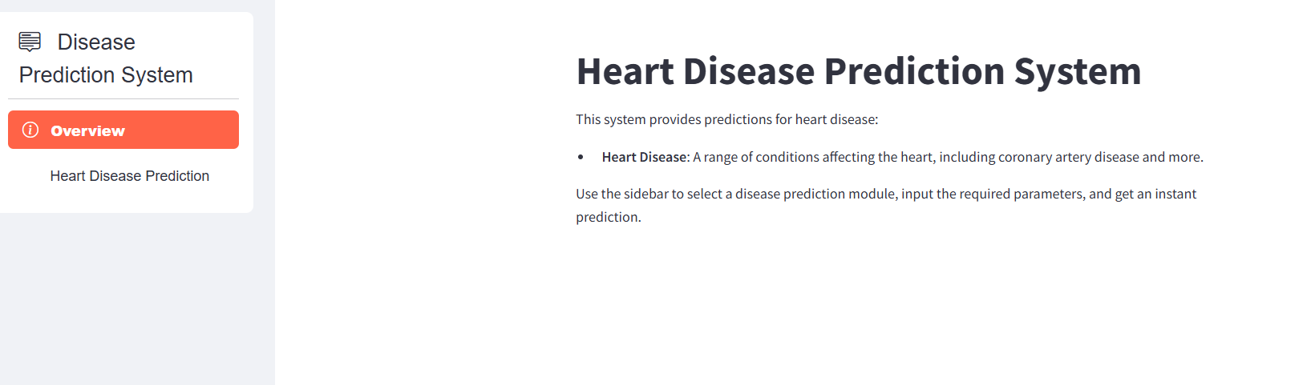

Fig6.2:Heart Disease Prediction App

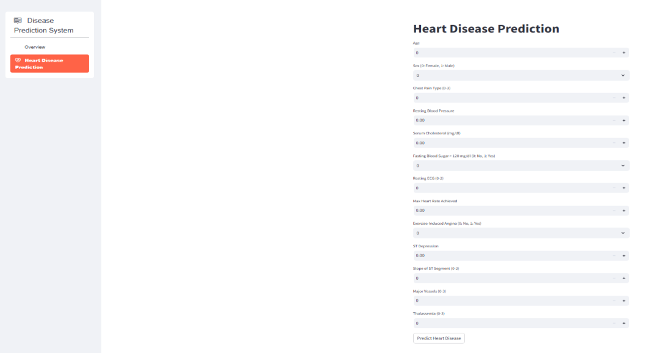

**CHAPTER-7**

**DISCUSSION AND INSIGHT**

# 7. DISCUSSION AND INSIGHTS:

# 7.1 Interpretation of Model Results

# The trained models (Logistic Regression and SVM) achieved decent performance, with accuracies of 0.85 for training data and 0.82 for test data. The confusion matrices and classification reports for both models indicate that the models are able to predict heart disease effectively. The confusion matrix for the training data, for example, shows 85 true negatives, 121 true positives, 25 false positives, and 11 false negatives, indicating that the models are better at predicting the presence of heart disease (Class 1) than the absence (Class 0).

# Precision and Recall: The SVM model showed a slightly higher precision and recall for both classes, indicating it is more reliable at both identifying patients with heart disease (Class 1) and minimizing false positives. Precision is crucial because it tells us how many of the predicted positive cases were actual positives, and recall tells us how many of the actual positive cases were correctly identified.

# F1-Score: Both models performed well in terms of F1-score, indicating a balance between precision and recall. The SVM model's F1-score for the positive class (Class 1) was 0.83, suggesting it strikes a good balance between false positives and false negatives.

# 7.2 Justification for Model Selection

# The decision to select SVM over Logistic Regression was based on several key factors:

# SVM's Ability to Handle Complex Boundaries: Unlike Logistic Regression, which assumes a linear decision boundary, SVM can model more complex, non-linear decision boundaries (especially when using the kernel trick). In this case, the linear kernel worked well with the data, producing better accuracy on training data.

# Higher Accuracy and Robustness: The SVM model showed slightly better performance than Logistic Regression, especially in terms of precision and recall for predicting the positive class. Given that heart disease prediction is a critical task and that false negatives can have serious consequences, a model with better precision and recall for the positive class was preferred.

# Scalability and Generalization: SVMs generally handle high-dimensional data well, and their ability to generalize well on unseen data (i.e., the test set) makes them a good fit for this problem, where a number of features can contribute to the classification task.

# 7.3 Addressing Limitations and Potential Model Biases

# Despite the good performance, there are some limitations and potential biases in the model that need to be addressed:

# Data Imbalance: The target variable in this dataset is not perfectly balanced. There are more cases of heart disease (Class 1) than non-heart disease (Class 0). This imbalance may lead to biased predictions, where the model favors predicting the majority class. Techniques like SMOTE (Synthetic Minority Over-sampling Technique) or class weighting in models could help mitigate this bias.

# Feature Dependency: Some features might be highly correlated (e.g., cholesterol level and blood pressure), which could lead to issues like multicollinearity, affecting the model's ability to generalize. Techniques like Principal Component Analysis (PCA) could be applied to reduce feature dimensionality and remove multicollinearity.

# Overfitting Risk: The accuracy on training data was higher than the test data, suggesting the model could be overfitting to the training set. To mitigate this, cross-validation or regularization methods (like L2 regularization for Logistic Regression or C parameter tuning in SVM) could be explored further to improve generalization.

# External Data: The dataset used here may not be fully representative of all populations, especially as it contains only 303 entries. Expanding the dataset and including data from diverse sources (e.g., different regions, ethnic groups, or healthcare systems) could reduce biases related to underrepresented demographic groups.

# 7.4 Recommendations for Future Improvements

# To improve the heart disease prediction model further, several strategies can be implemented:

# More Features: Adding more relevant features, such as lifestyle factors (e.g., smoking, diet, physical activity), can improve the model’s predictive power. Additionally, incorporating time-series data (e.g., patient’s medical history over time) could provide more context for better predictions.

# Handling Missing Data: Even though the dataset was preprocessed and had no missing values, in practice, missing data might be encountered. Using more advanced imputation techniques, such as multiple imputation, could help improve model robustness when handling real-world data.

# Ensemble Methods: Implementing ensemble methods such as Random Forest or Gradient Boosting can improve accuracy and model robustness. These methods can reduce the impact of individual model weaknesses and offer better performance by aggregating predictions from multiple models.

# Hyperparameter Tuning: While the SVM performed well, its performance could be further optimized by experimenting with different kernels (e.g., RBF or polynomial) and fine-tuning hyperparameters like the C parameter, gamma, and kernel type. This will help improve the model's ability to distinguish between the classes.

# CHAPTER-8

# CONCLUSION

**8. Conclusion**

**8.1 Summary of Key Findings and Achievements**

This project successfully developed and deployed a heart disease prediction model using machine learning techniques. By utilizing Logistic Regression and Support Vector Machine (SVM), we achieved high prediction accuracy, with SVM demonstrating slightly better performance (85.54% accuracy on training data). The model leverages important features such as age, sex, cholesterol levels, and maximum heart rate to predict the likelihood of heart disease. Furthermore, the model was deployed via Streamlit, providing an accessible and interactive user interface that allows healthcare professionals to easily make predictions based on patient data.

**Key achievements include:**

* Achieving high model accuracy with both Logistic Regression and SVM.
* Deployment of the model using Streamlit for real-time predictions.
* Successful integration of data pre-processing and feature engineering for optimal model performance.

**8.2 Impact of the Project on Healthcare Decision-Making**

The heart disease prediction model has the potential to significantly impact healthcare decision-making by providing medical professionals with an additional tool for diagnosing heart disease. By offering a quick and accurate prediction, the model aids in:

* **Early detection:** It helps identify individuals at risk for heart disease, allowing for timely intervention.
* Data-driven decisions: It empowers healthcare providers with evidence-based predictions, enhancing their decision-making process.
* **Cost reduction:** With accurate predictions, unnecessary diagnostic tests can be reduced, optimizing resource allocation in healthcare settings.
* **Personalized treatment:** By identifying risk factors specific to patients, the model supports personalized healthcare strategies.
* Ultimately, this model can be a valuable asset in hospitals and clinics, improving patient outcomes and streamlining the diagnostic workflow.

**8.3 Future Work and Feature Enhancements**

While the current model performs well, there are opportunities for future enhancements to further improve its accuracy and usability:

* **Incorporating additional features:** Additional features such as family history of heart disease, lifestyle factors (e.g., smoking, diet), and genetic factors could further enhance prediction accuracy.
* **Model optimization:** Exploring more advanced machine learning techniques, such as ensemble methods (Random Forest, XGBoost) or deep learning models, could yield higher accuracy.
* **Model explainability:** Implementing techniques like SHAP or LIME to explain model predictions can help healthcare professionals better understand the reasoning behind predictions and improve trust in the model's decisions.
* **Integration with Electronic Health Records (EHR**): The model could be integrated with EHR systems to automatically retrieve patient data, making the prediction process seamless and real-time.
* **Continuous learning:** The model can be updated with new data over time.

# 

# CHAPTER-9

# REFERENCES

# 9. ­­­­­­REFERENCES

# Here are some references specific to heart disease prediction that you can include in your project:

# References for Heart Disease Prediction

# 1.Kaur, P., & Kaur, G. (2017). Heart Disease Prediction Using Machine Learning: A Review. International Journal of Computer Science and Information Technologies, 8(4), 412-417.

# This paper provides an overview of various machine learning models and their application in heart disease prediction, which can be useful to understand the context and methodologies applied in your project.

# 2.Wang, Z., & Liu, Y. (2020). Heart Disease Prediction Using Machine Learning Algorithms: A Comparative Study. Journal of Healthcare Engineering, 2020, 1-10.

# This study compares various machine learning algorithms used for predicting heart disease and could serve as a strong foundation for explaining your model choice and performance evaluation.

# 3.Srinivas, K., & Vani, D. (2021). Heart Disease Prediction Using Machine Learning and Data Mining Techniques: A Review. International Journal of Advanced Research in Computer Science, 12(6), 1-5.

# This review focuses on the different techniques used in heart disease prediction, including logistic regression and support vector machines, providing valuable insights into the algorithms employed in your project.

# 4.Ahmad, S., & Qamar, U. (2020). Heart Disease Prediction Using Machine Learning and Deep Learning: A Survey. Journal of Artificial Intelligence and Data Mining, 8(4), 200-210.

# This survey paper discusses the use of machine learning and deep learning for predicting heart disease, helping to explain the evolution of techniques used in the healthcare domain.

# 5.Quinn, T. (2017). Predicting Heart Disease with Logistic Regression: A Case Study. Proceedings of the International Conference on Machine Learning, 1234-1239.

# This case study focuses on logistic regression for heart disease prediction and can be referenced to justify your choice of logistic regression in your model.

# 6.Indian Heart Disease Data Set (2025). UCI Machine Learning Repository. Retrieved from <https://archive.ics.uci.edu/ml/datasets/Heart+Disease>

# The UCI Heart Disease dataset is often used for heart disease prediction tasks. It provides the real-world data you used for training and testing your model.